Nama : Samudra Bryandhika Prakoso

Kelas : PPTI 21

NIM : 2802538750

Canva element :

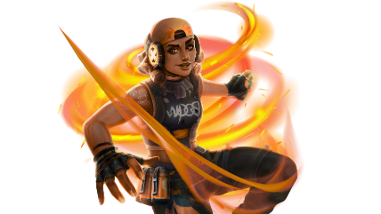

Link : <https://wallpapersden.com/raze-new-valorant-wallpaper/>

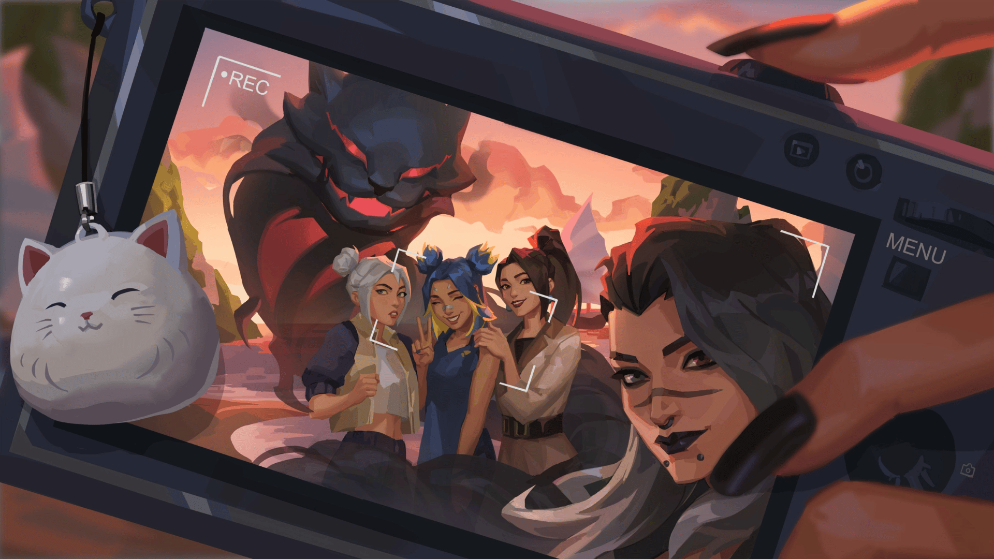

Link : <https://wallpapersden.com/valorant-hd-selfiee-wallpaper/>

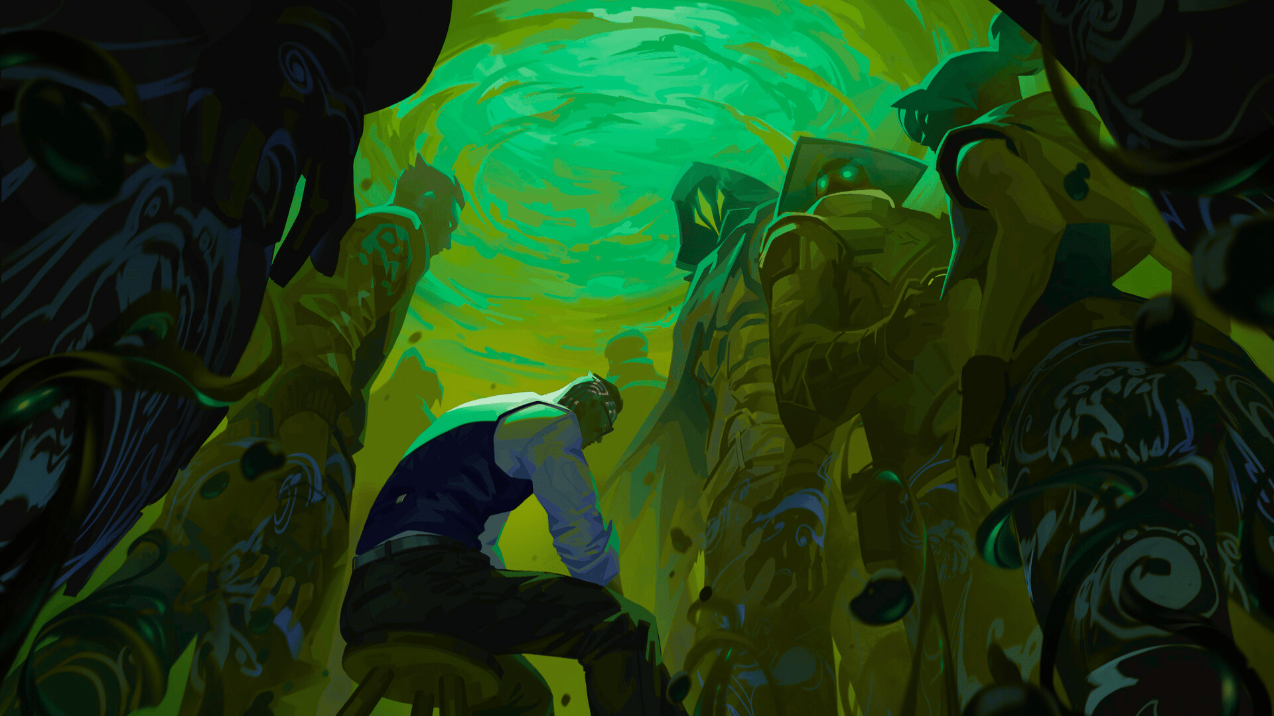

Link : <https://wallpapersden.com/valorant-hd-cool-digital-2022-art-wallpaper/>

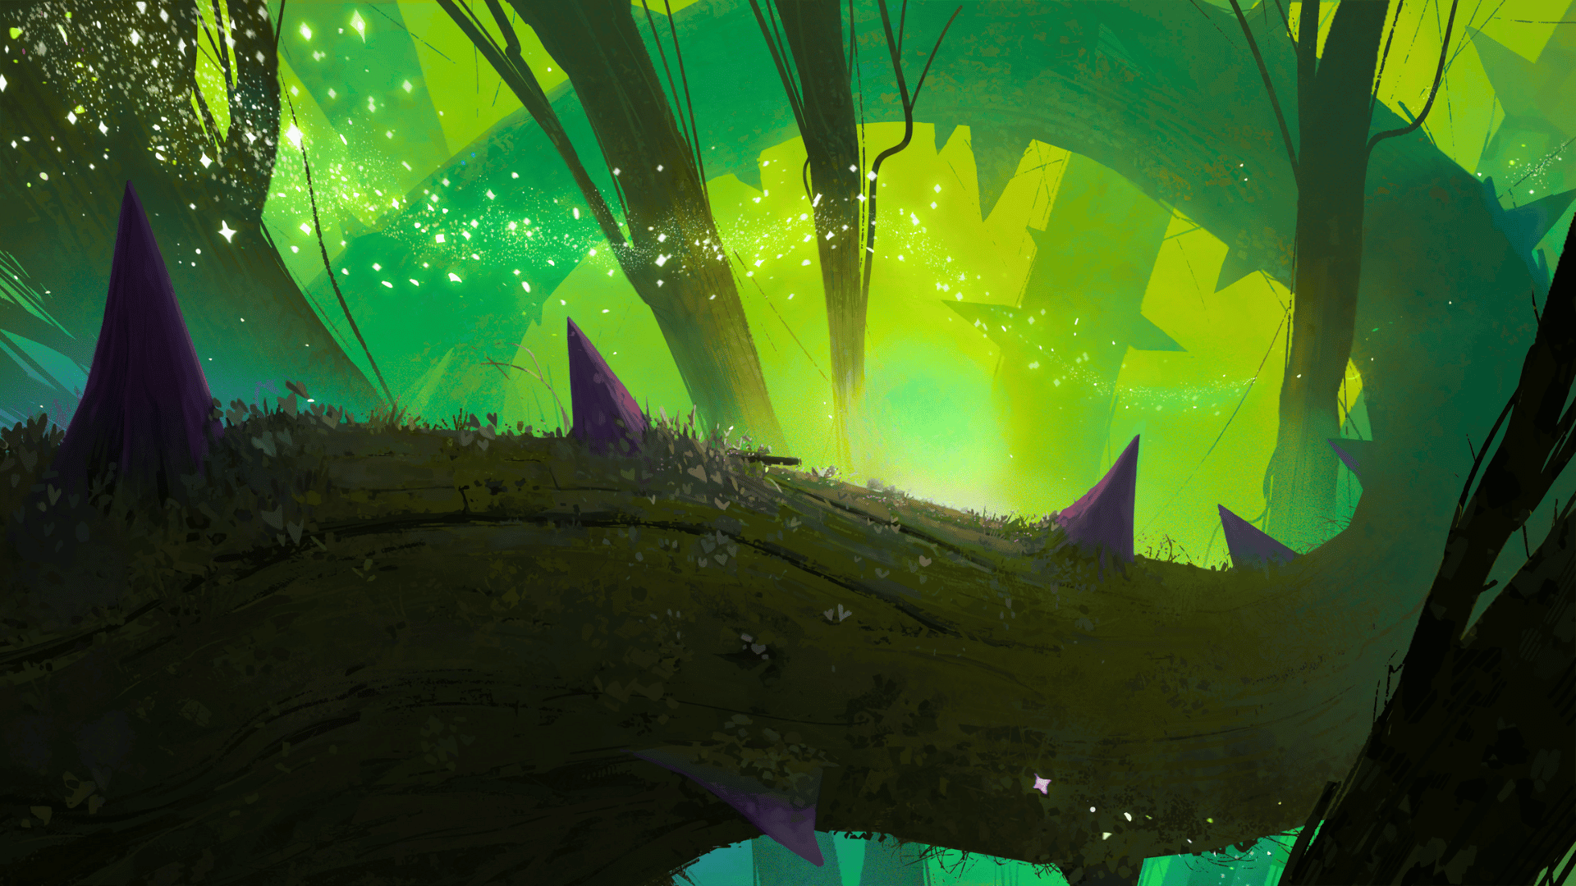

Link : <https://wallpapersden.com/searching-for-the-light-hd-digital-wallpaper/>

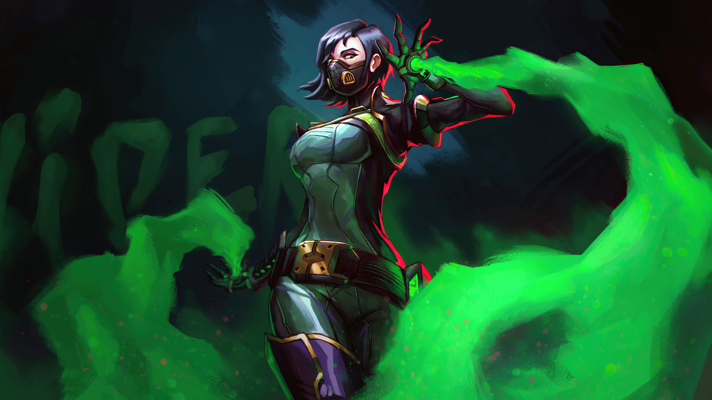

Link : <https://wallpapersden.com/viper-4k-valorant-2020-wallpaper/>

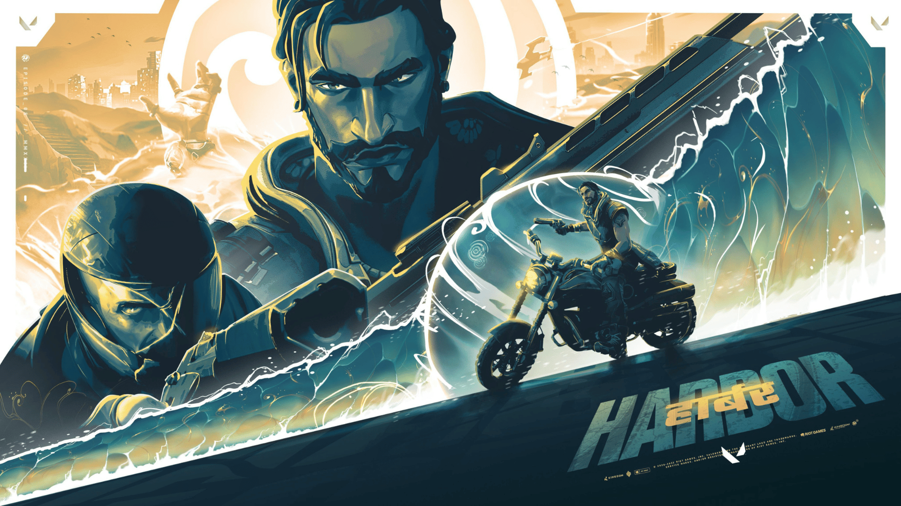

Link : <https://wallpapersden.com/harbor-cool-valorant-gaming-wallpaper/>

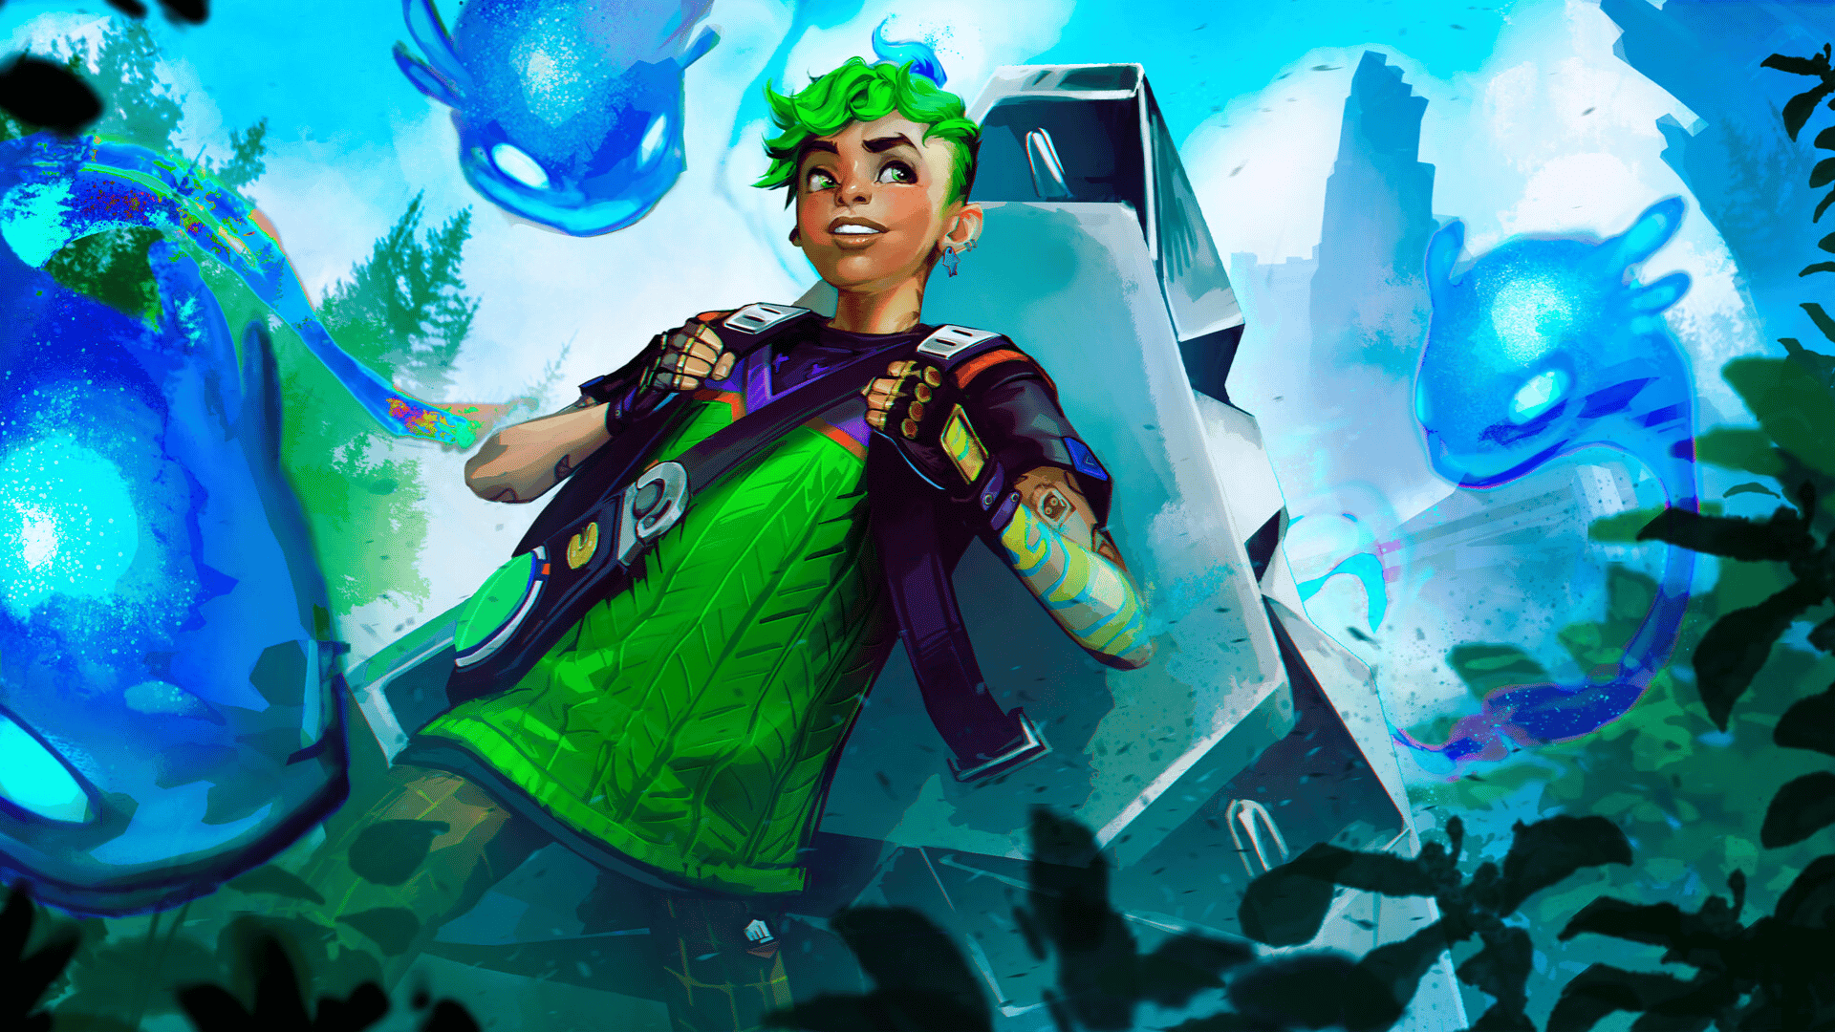

Link : <https://wallpapersden.com/gekko-hd-valorant-wallpaper/>

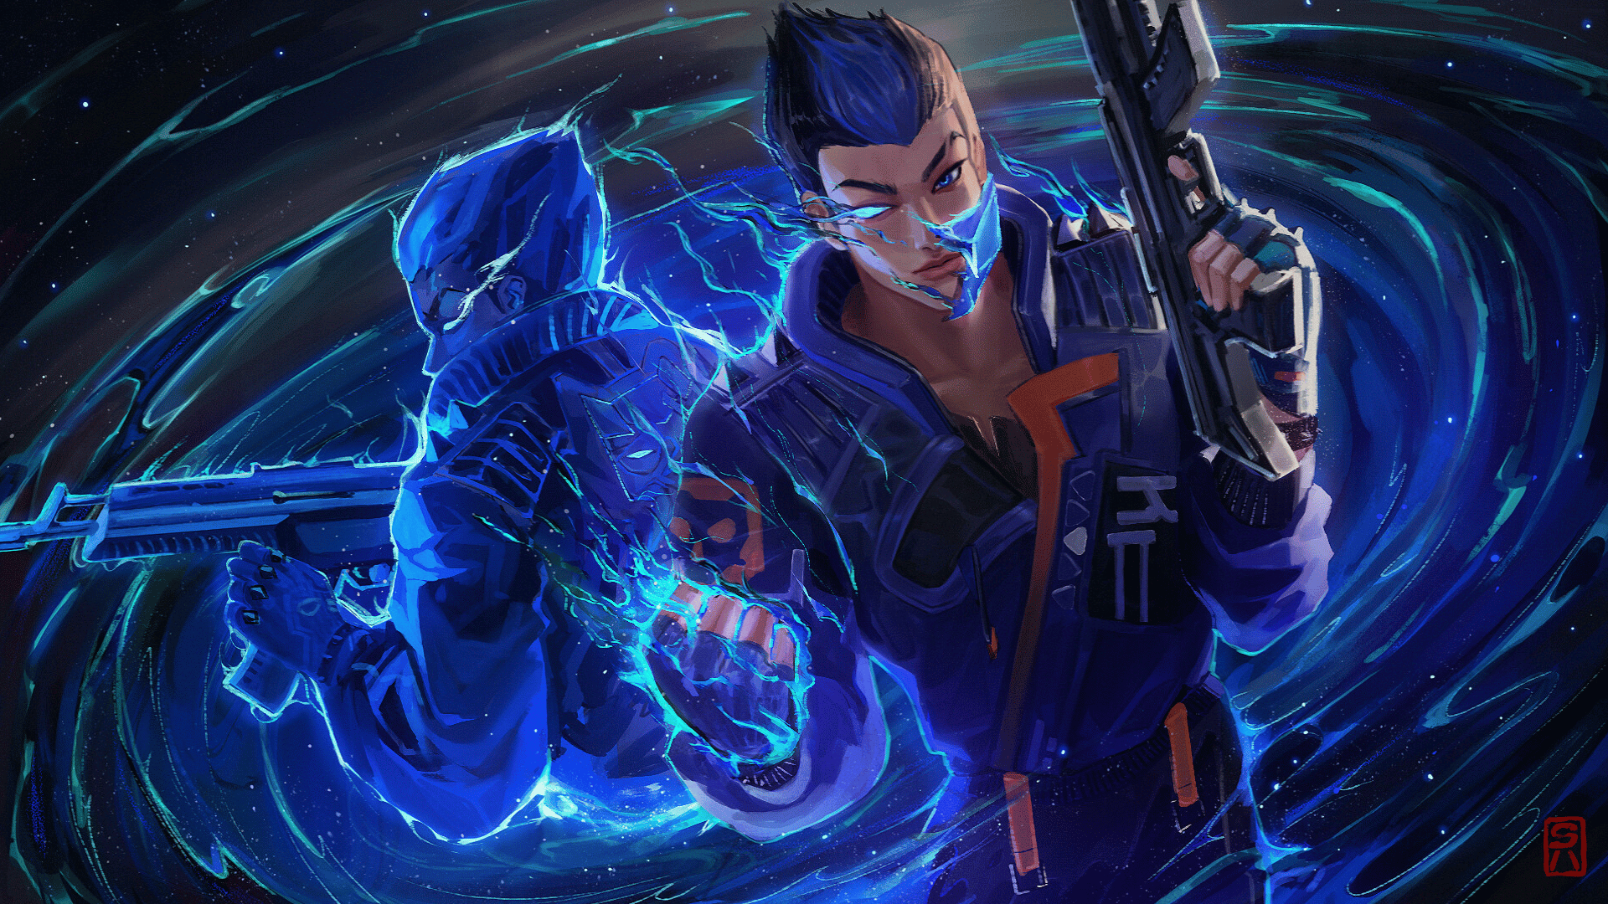

<https://wallpapersden.com/yoru-fan-art-valorant-wallpaper/>

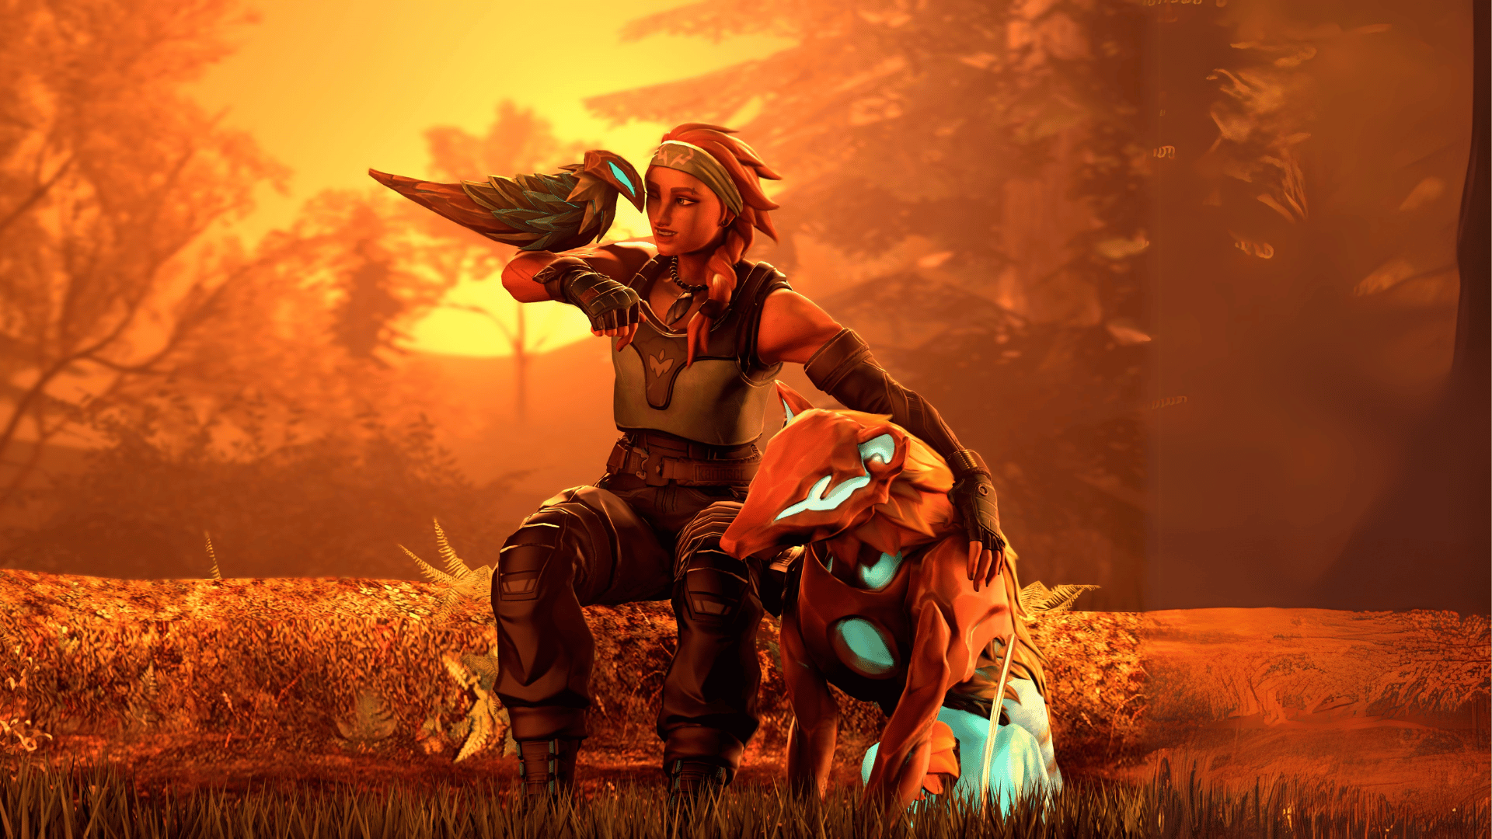

Link : <https://wallpapersden.com/skye-art-cool-valorant-wallpaper/>

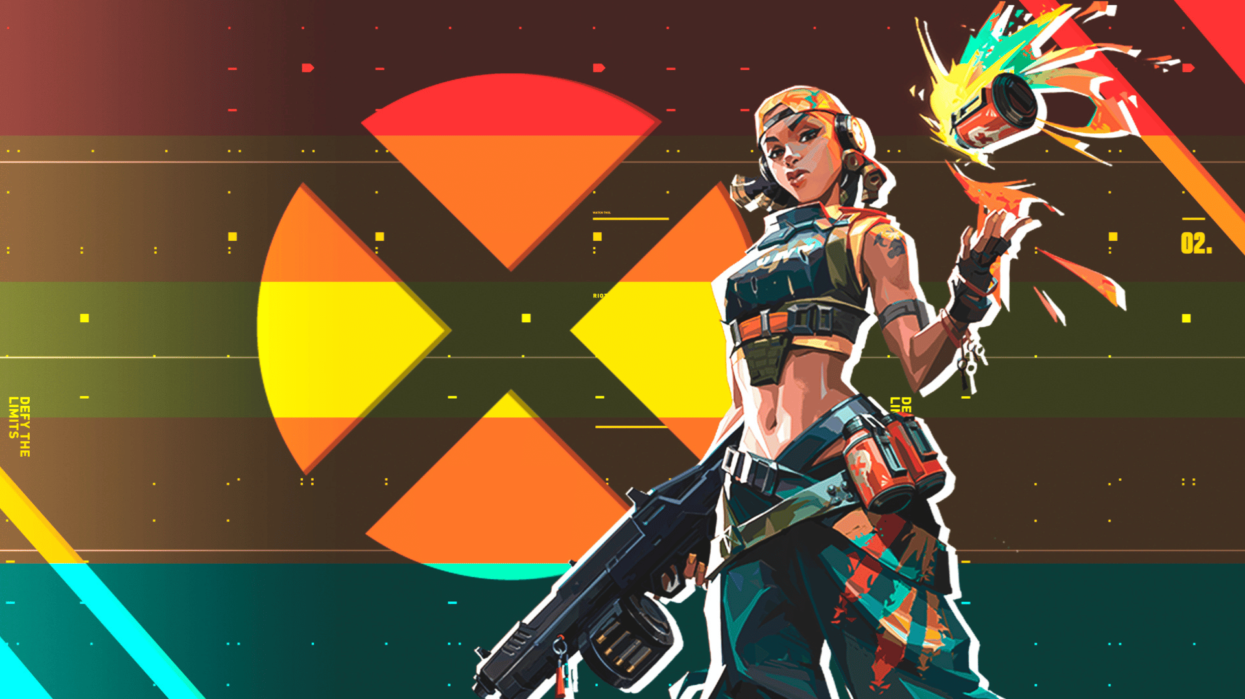

Link : <https://wallpapersden.com/raze-valorant-xbox-wallpaper/>

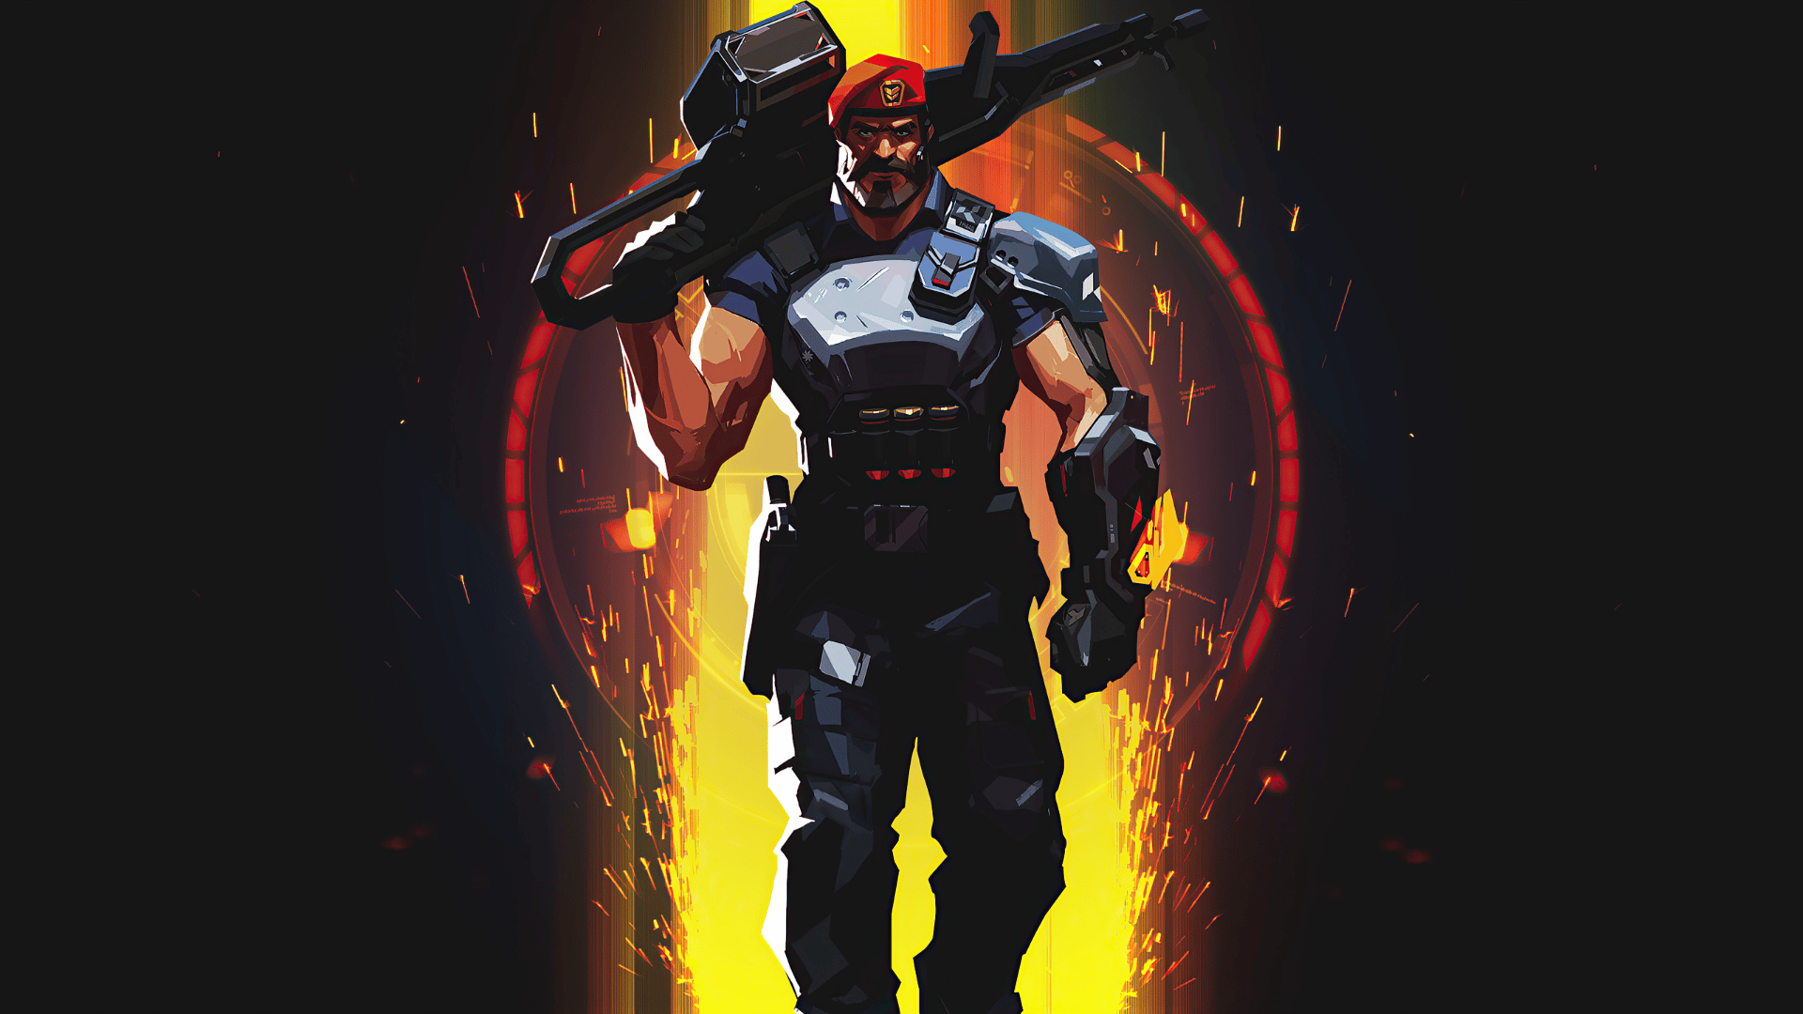

Link : <https://wallpapersden.com/brimstone-new-valorant-poster-wallpaper/>

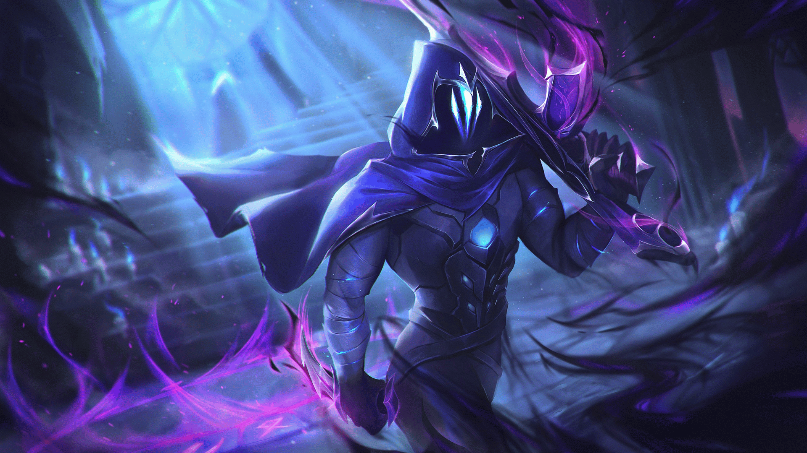

Link : <https://wallpapersden.com/cool-omen-valorant-2023-wallpaper/>

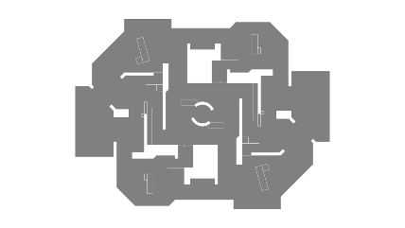

Link : <https://liquipedia.net/valorant/Kasbah>

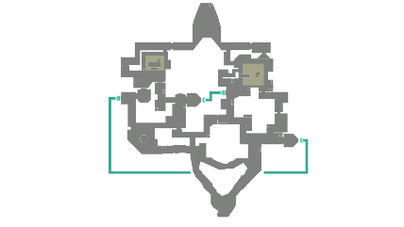

Link : <https://liquipedia.net/valorant/Bind>

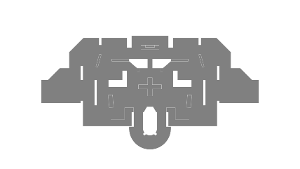

Link : <https://liquipedia.net/valorant/District>

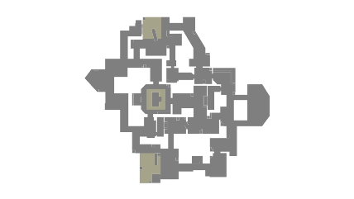

Link : <https://liquipedia.net/valorant/Haven>

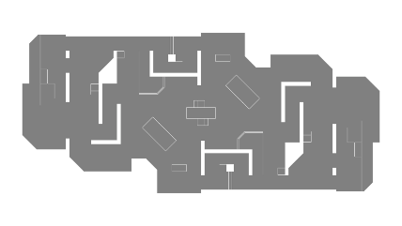

Link : <https://liquipedia.net/valorant/Piazza>

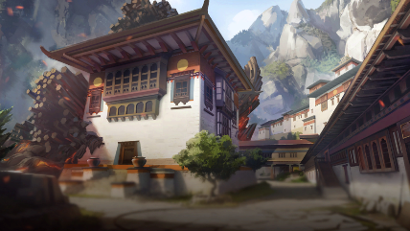

Link : <https://liquipedia.net/valorant/File:Haven_Map.png>

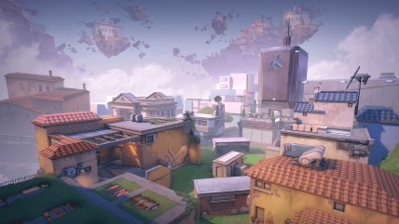

Link : <https://liquipedia.net/valorant/File:Piazza_Map.png>

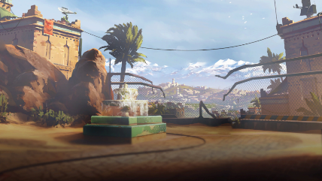

Link : <https://liquipedia.net/valorant/File:Bind_Map.png>

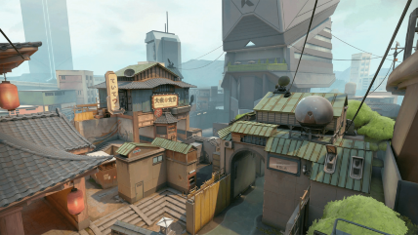

Link : <https://liquipedia.net/valorant/File:District_Map.png>

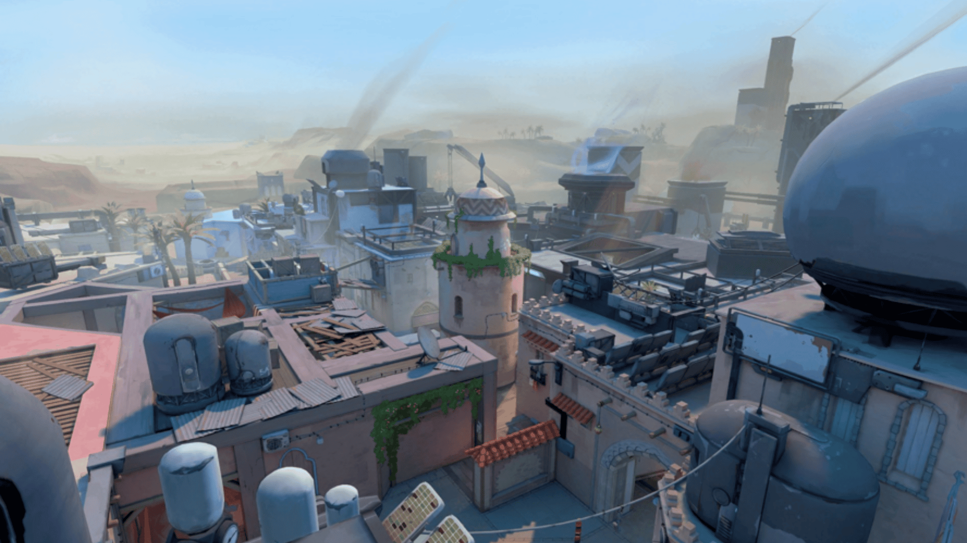

Link : <https://liquipedia.net/valorant/File:Kasbah_Map.png>

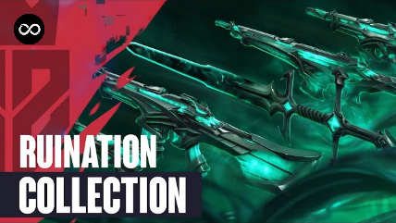

Link : <https://i.ytimg.com/vi/MDFwJXOG5-k/hq720.jpg?sqp=-oaymwEhCK4FEIIDSFryq4qpAxMIARUAAAAAGAElAADIQj0AgKJD&rs=AOn4CLAh8R4sNvR6PE3tpaxc_LfV_nuHuQ>

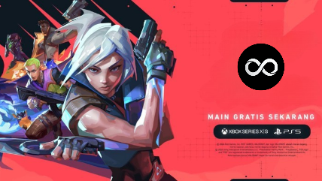

Link : <https://inet.detik.com/games-news/d-7474880/valorant-resmi-hadir-di-ps5-dan-xbox-series-x-s>

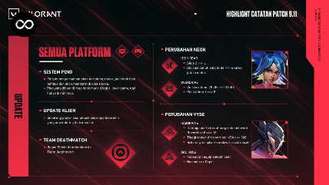

Link : <https://playvalorant.com/id-id/news/game-updates/valorant-patch-notes-9-11/>

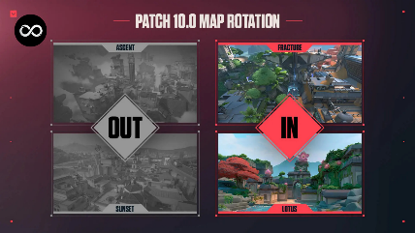

Link : <https://x.com/VALORANT/status/1859990737313493106>

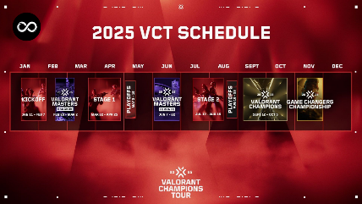

Link : <https://dailyspin.id/esports/valorant/valorant-champions-tour-vct-2025-pembaruan-dan-perubahan-penting/>

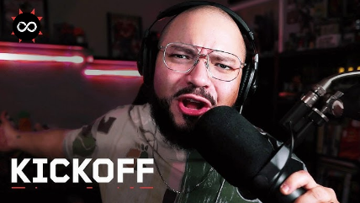

Link : <https://i.ytimg.com/vi/YU_1hne0HQc/hq720.jpg?sqp=-oaymwEhCK4FEIIDSFryq4qpAxMIARUAAAAAGAElAADIQj0AgKJD&rs=AOn4CLBZB3Qae-lpkUUn7xBI16kj6jQfJg>

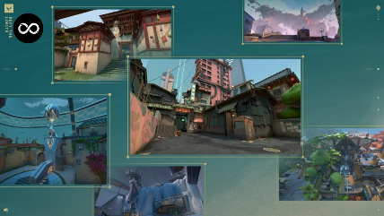

Link : <https://premate.gg/blog/how-to-improve-your-valorant-gameplay/>

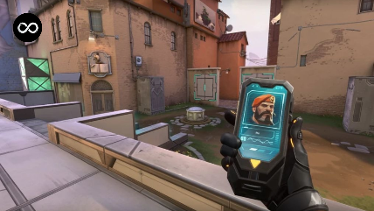

Link : <https://www.medcom.id/teknologi/game/5b2wo56k-valorant-luncurkan-fitur-flex-untuk-ekspresikan-gaya-pemain>



Link : <https://valorant.fandom.com/wiki/Reyna>



Link : <https://valorant.fandom.com/wiki/Jett>



Link : <https://valorant.fandom.com/wiki/Brimstone>



Link : <https://valorant.fandom.com/wiki/Sage>

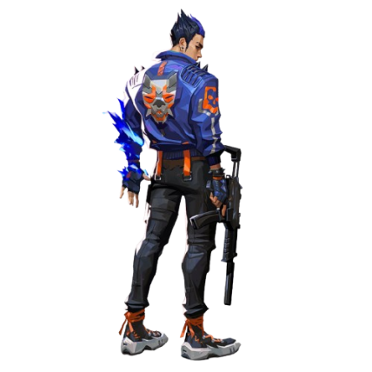

Link : <https://www.citypng.com/photo/16603/hd-valorant-game-yoru-agent-character-player-png>

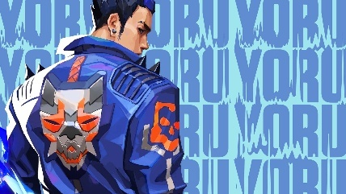

Link : <https://wall.alphacoders.com/big.php?i=1125089>

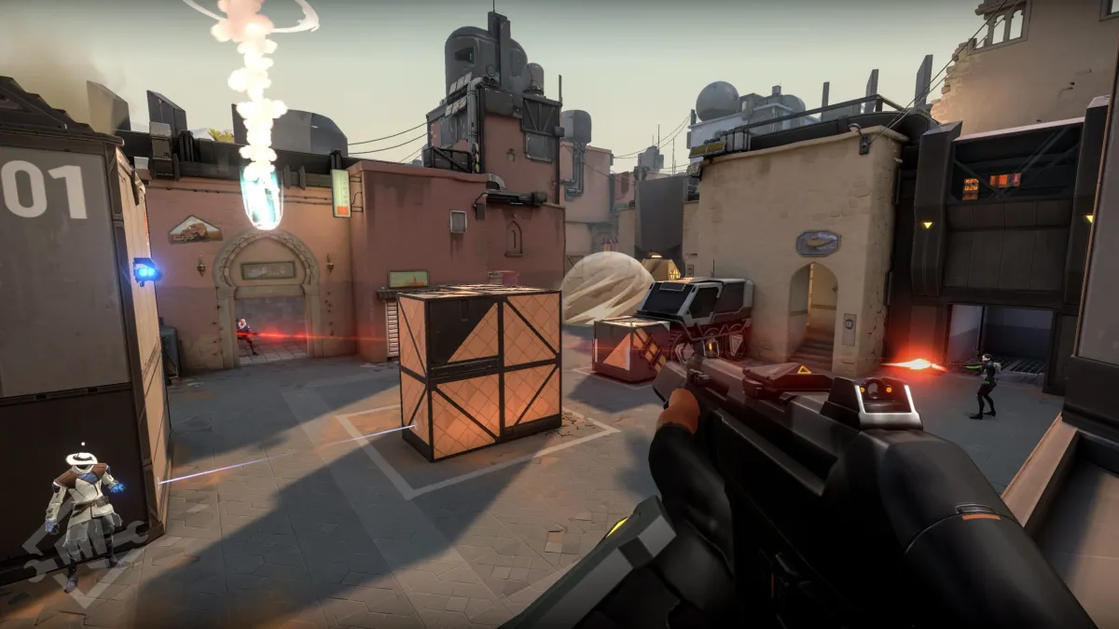

Link : <https://www.thegamer.com/valorant-game-best-worst-things/>

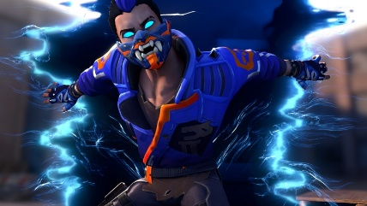

Link : <https://gamerant.com/valorant-yoru-guide-tips/>

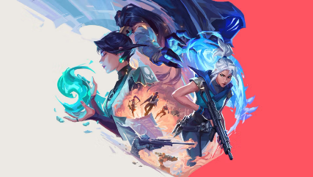

Link : <https://playvalorant.com/id-id/news/tags/cypher/>

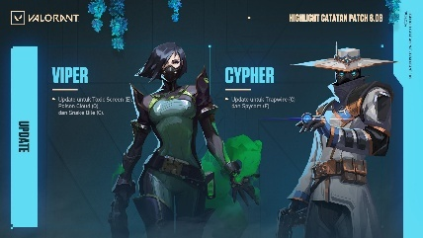

Link : <https://playvalorant.com/id-id/news/game-updates/valorant-patch-notes-8-08/>

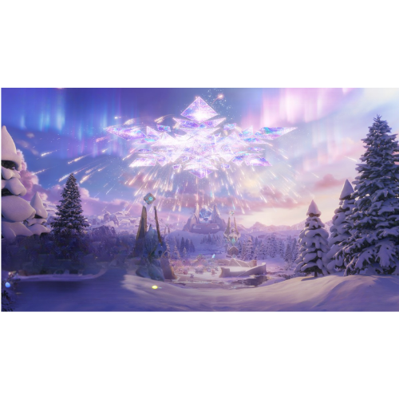

Link : <https://www.oneesports.id/honor-of-kings/event-winter-dreamland-hok-hadiah/>

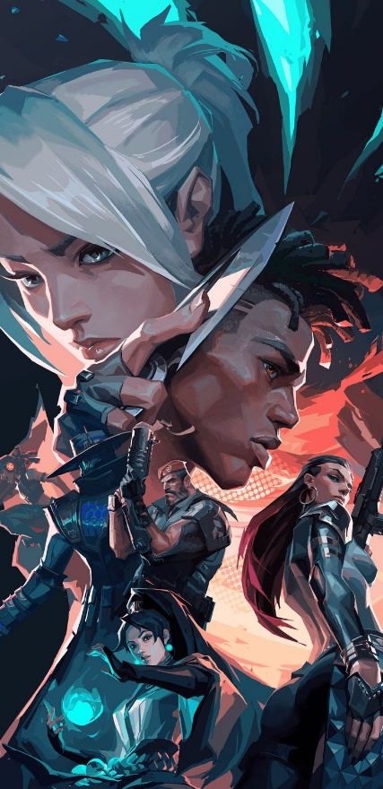

Link : <https://in.pinterest.com/pin/832110468645925643/>

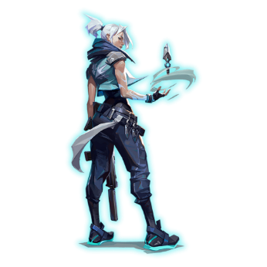

Link : <https://www.citypng.com/photo/6002/hd-jett-agent-valorant-character-png>

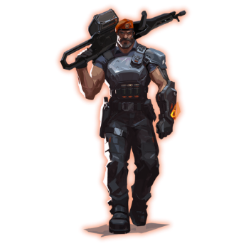

Link : <https://www.citypng.com/photo/5980/hd-brimstone-valorant-agent-player-character-png>

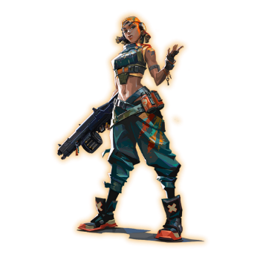

Link : <https://www.citypng.com/photo/7518/hd-raze-valorant-game-female-character-player-png>

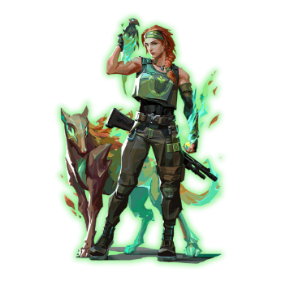

<https://www.citypng.com/photo/9604/hd-valorant-skye-female-agent-character-player-png>

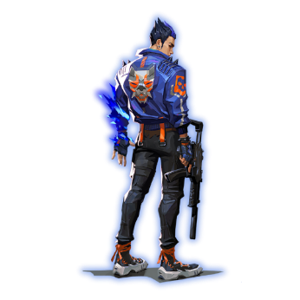

Link : <https://www.citypng.com/photo/16603/hd-valorant-game-yoru-agent-character-player-png>

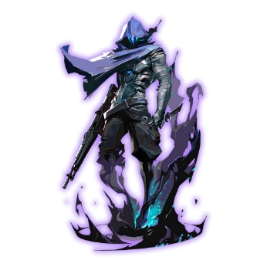

Link : <https://www.citypng.com/photo/7383/hd-valorant-game-omen-character-player-png>

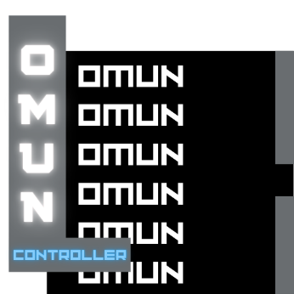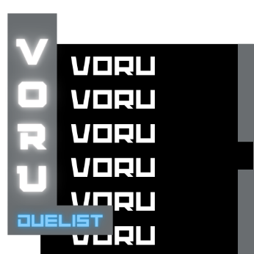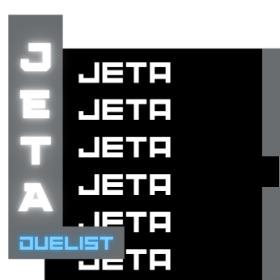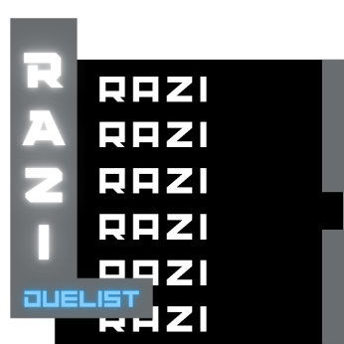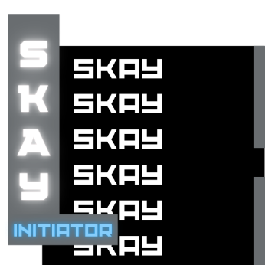

Saya membuat gambar ini di canva.

**FONT**

1. Lato-BoldItalic

Link : <https://fonts.google.com/specimen/Lato>

1. RacingSansOne-Regular

Link : <https://fonts.google.com/specimen/Racing+Sans+One>

1. Transformers Movie

Link : <http://dafont.com/transformers-movie.font>

1. Valorant

Link : <https://www.dafont.com/valorant.font>